Swim Lesson Instructors 2018
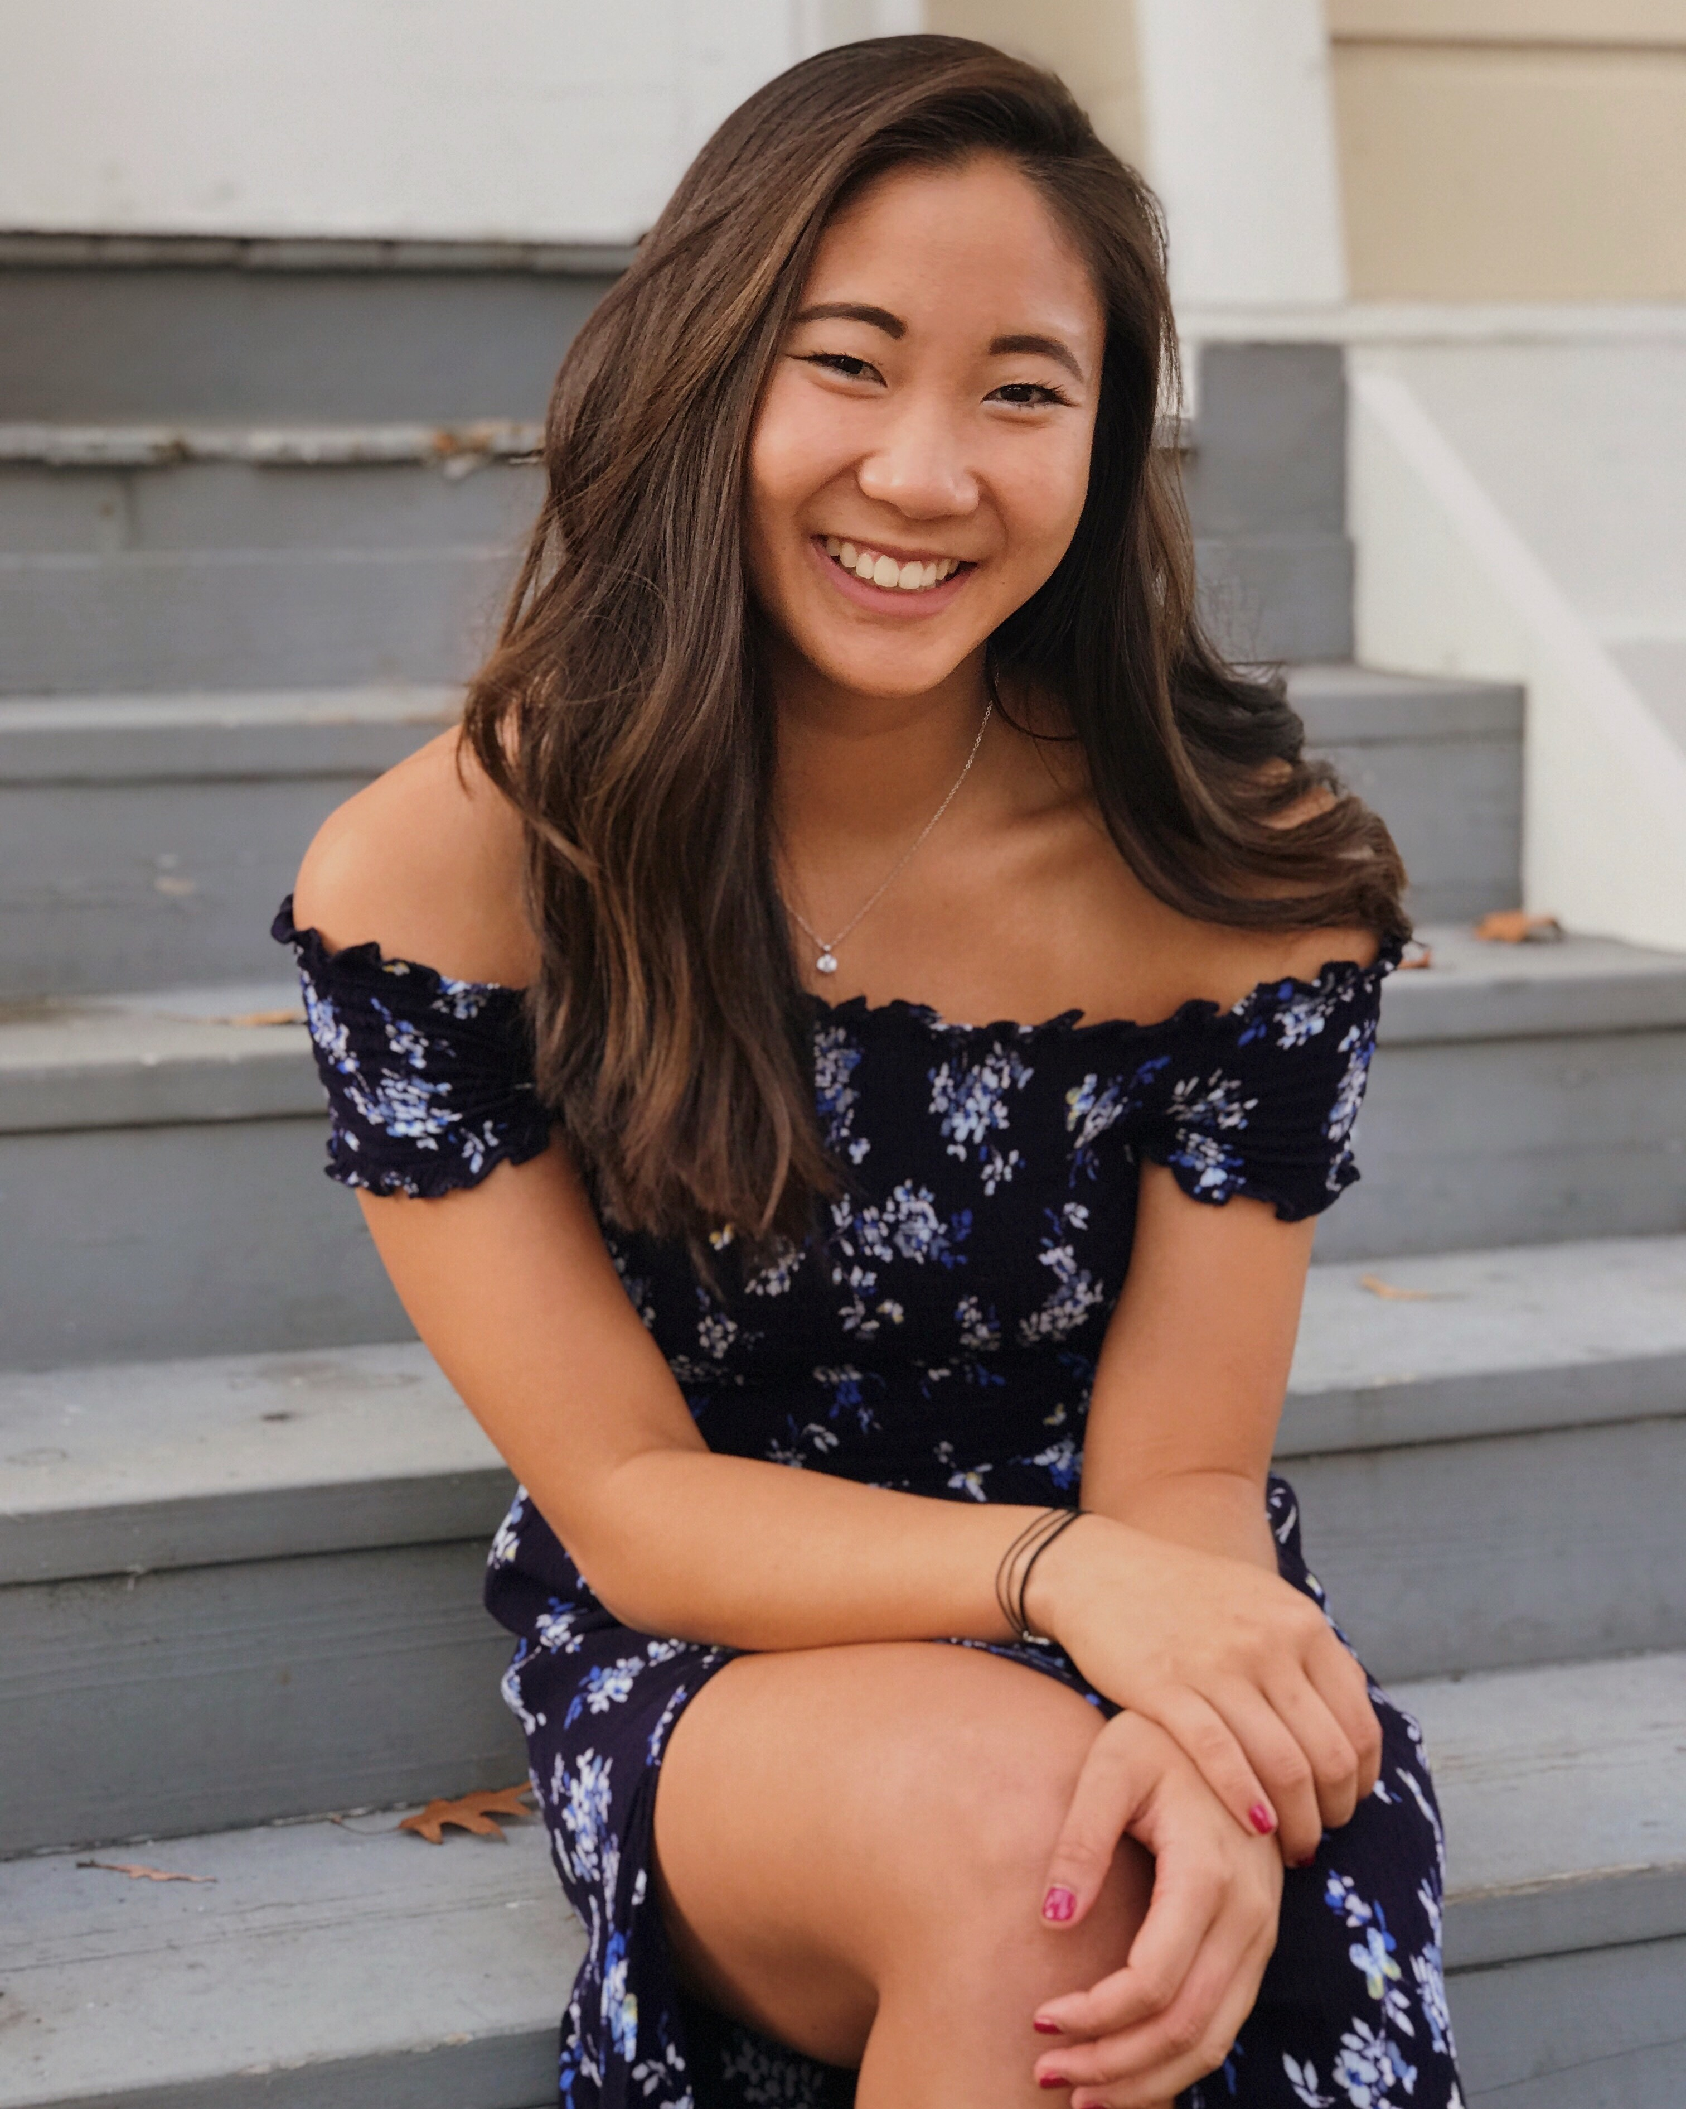

Kristina Fong (Swim Lesson Manager)

Hi, my name is Kristina and I’m a Senior Kinesiology major at Chapman University. In high school, I swam on three teams (Saint Francis High School, De Anza Cupertino Aquatics National Team, and Saratoga Woods) and I’m currently entering my fourth swim season at Chapman. I’m also lifeguarding this year at Saratoga Woods. This is my sixth year as an instructor and I love working with kids of all ages and skill levels. However, I excel at improving swim technique for races.

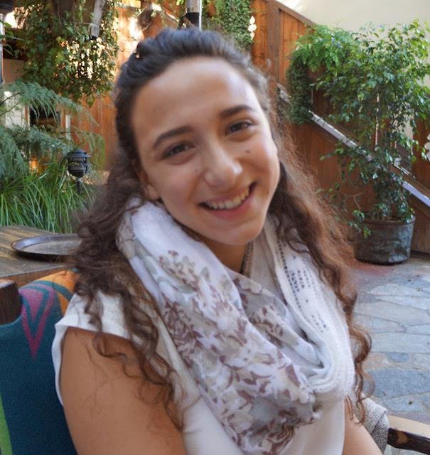
Ariela Guadiamos

I will be a junior at Cal Poly San Luis Obispo in the fall. I swam for Saratoga Woods Swim Team, my high school swim team, De Anza Cupertino Aquatics, and currently swim on Cal Poly's Swim Club. This is my fourth year as an instructor, and I especially love working with older swimmers wanting to improve their technique. I have worked with kids of all ages, helping them learn to swim and love the water.

Trevor Perey

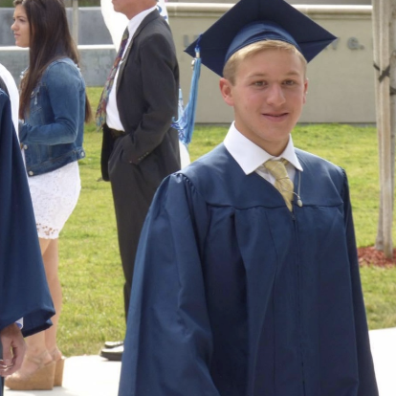
Hello! My name is Trevor Perey. I have been swimming at Saratoga Woods since I was 6 years old, and my time at Saratoga Woods motivated me to engage in competitive swimming, which I have done since I was 10 years old. I just finished my first year at the University of Notre Dame and am teaching swim lessons for the third year this year. I specialize in teaching freestyle and butterfly but am able to teach a wide variety of basic skills and stroke techniques. Go Dolphins!

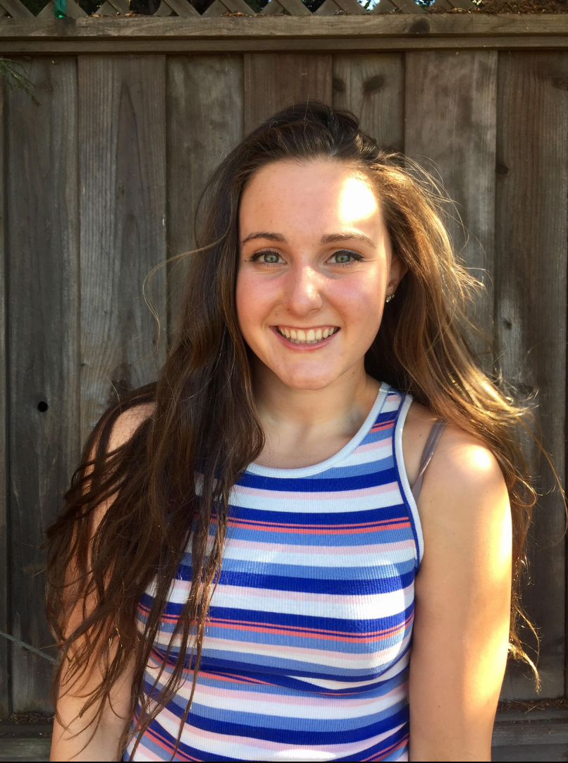
Rachael Tucker

My name is Rachael Tucker. I graduated from Archbishop Mitty High School this May and will be continuing my swimming and academic careers at the University of San Diego. I swam four years on Mitty Varisty swim team, will be continuing to swim on DACA's National team this summer, and here at Saratoga Woods (since she was 5 years old). I was trained by and worked for DACA as a swim instructor for children ages 3 to 12 years old, but love working with all ages. I will be lifeguarding this summer as well.

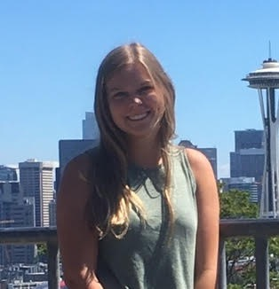
Laura Jewell

My name is Laura Jewell. This is my 3rd year as a lifeguard and swim instructor, 4th year as a coach for the swim team, and second year teaching Jr. Guards. I will be graduating from Saint Francis High school this year and attending Purdue University in the fall. I have been on the Saratoga Woods swim team since I was 4 years old and am excited to teach kids to be water safe and improve skills while still having fun!

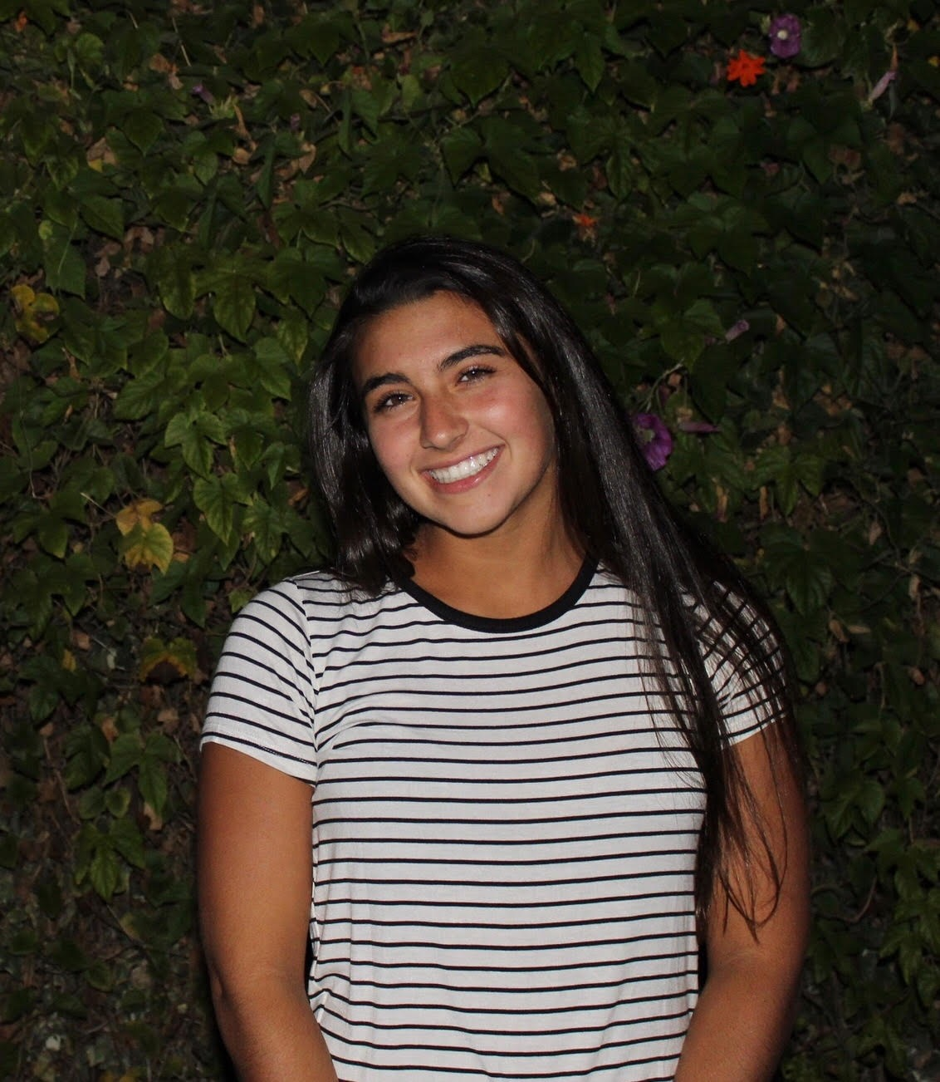
Emma Blackburn

My name is Emma Blackburn. This is my first year as a lifeguard and swim instructor at Saratoga Woods, but I have been teaching swim lessons for two years and lifeguarding for three years. I graduated from Saint Francis High School this year and will be attending Willamette University in the fall. I love playing water polo, soccer, running track, and swimming. I have been on a swim team since I was four years old and am excited to teach kids the skills they need to be safe and have fun in the water!

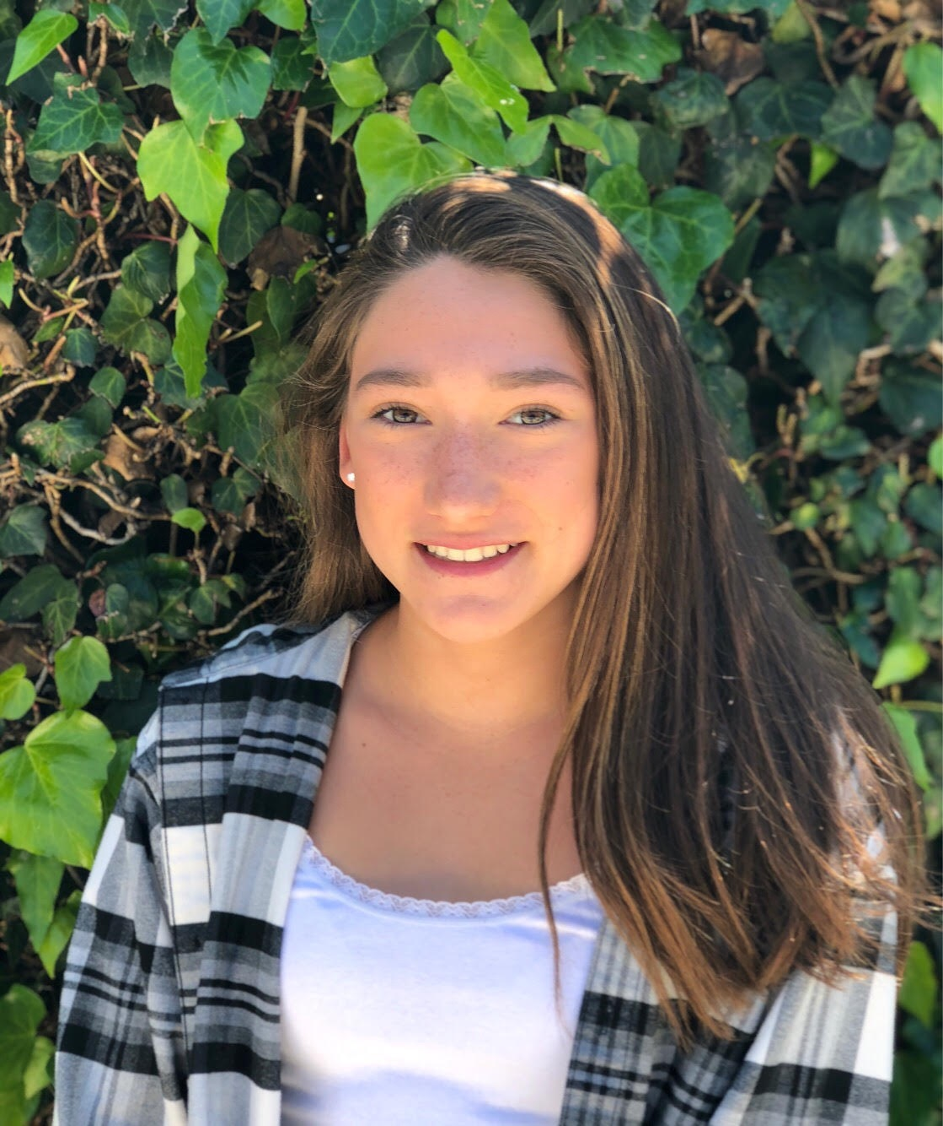
Isabella Guadiamos

My name is Isabella. This is my first year as a lifeguard and a swim instructor, but I have been coaching for Saratoga Woods for 2 years. I am a Junior at Monta Vista High School. I have been swimming for 10 years and am very excited to teach kids about the skills they need to be safe while also having fun in the water.

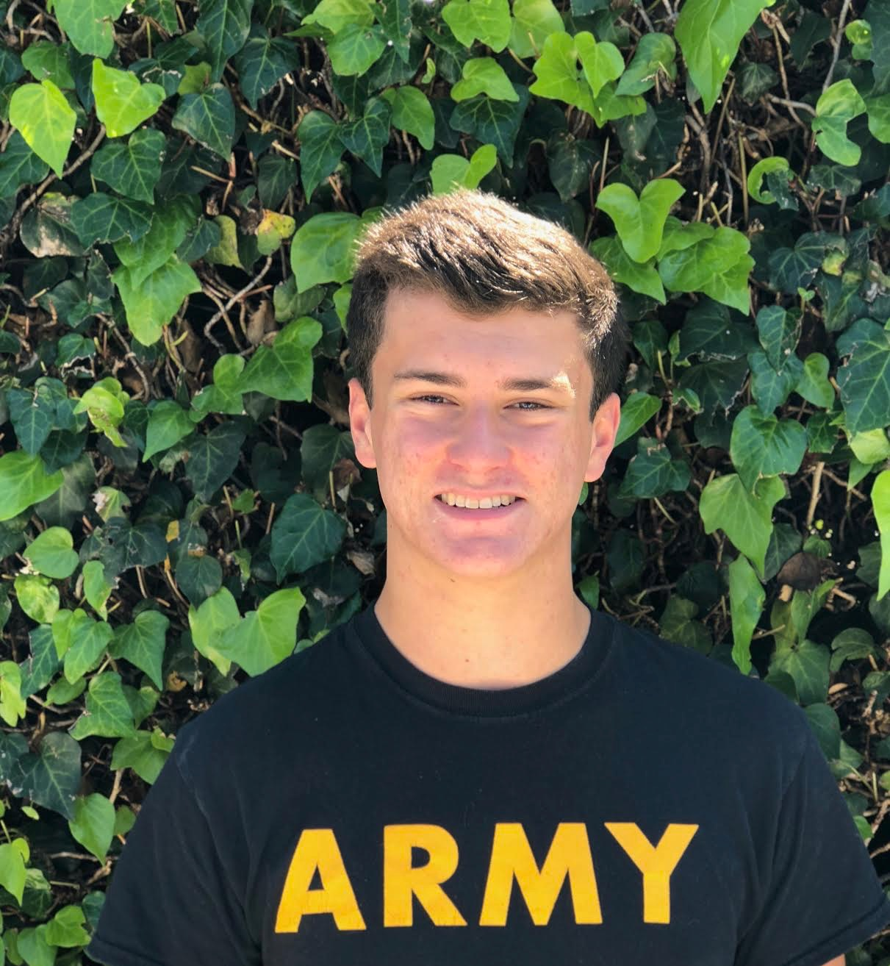
Ethan Taylor

My name is Ethan Taylor. This is my second year lifeguarding and my first year as a swim instructor. I am a Junior at Prospect high school. I love playing with my two dogs and enjoy swimming with friends. I have been on a swim team since I was 9 and am excited to be one of the kids I looked up to when I was younger. My favorite thing to teach in swim lessons is freestyle, backstroke and the flip turns for each.

Megan LaCroix

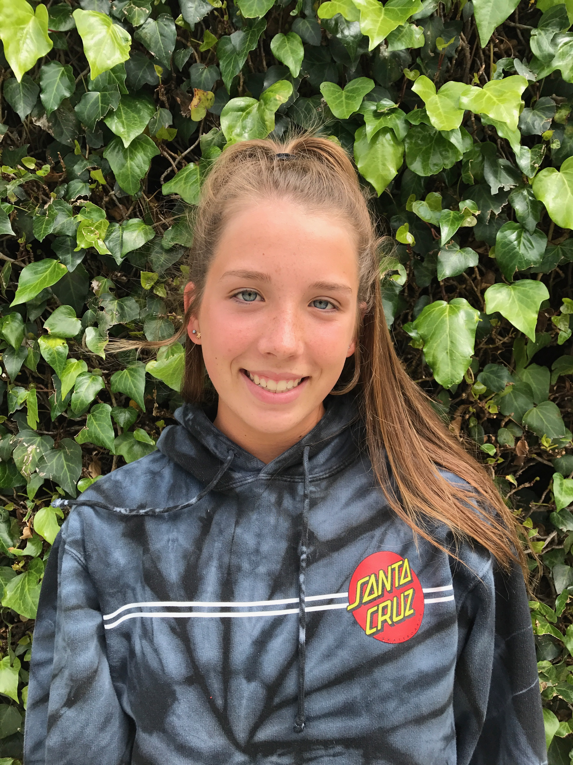
Hi I'm Megan Lacroix! I'm a junior in high school and this is my second year as a lifeguard. I've been swimming at Saratoga Woods since I was five years old and I live just down the street from the club. I also swam for DACA for five years and swim on the Saint Francis High School varsity swim team. In addition to swimming I play water polo in school and on a club team. I love swimming and playing water polo and can't wait to share my passion with kids. I enjoy working with kids of all ages and look forward to teaching lessons this year at Saratoga Woods.

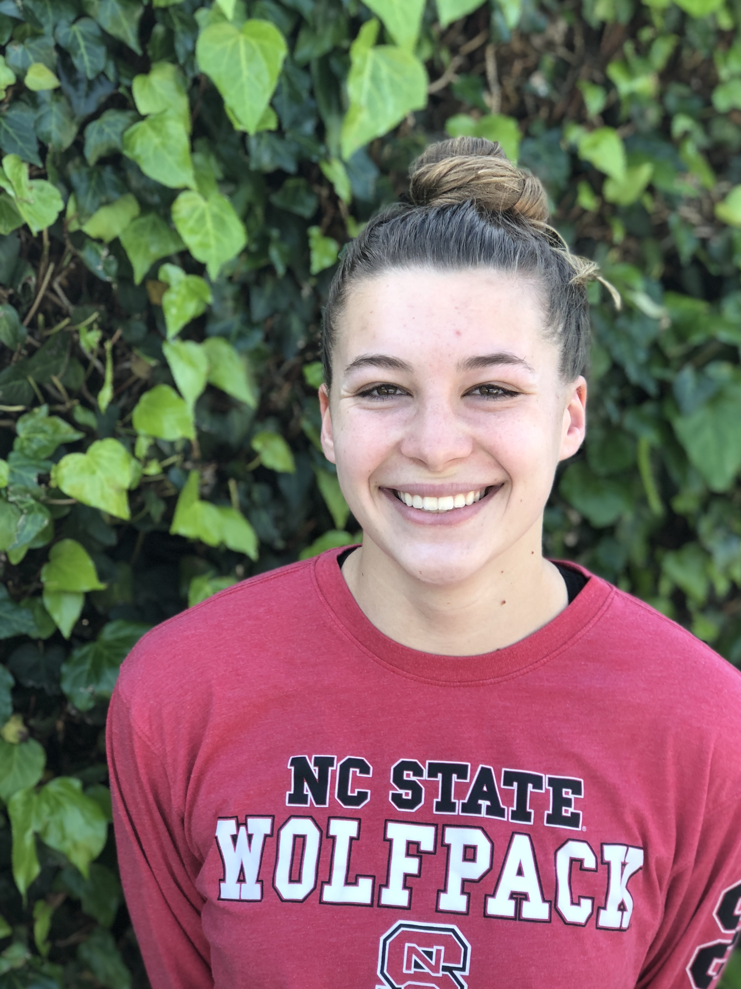

Elizabeth (Lizzie) Ball

My name is Elizabeth Ball. I will be a Senior at Saint Francis High School this Fall, where I play volleyball. I have been swimming at Saratoga Woods since I was 4 years old. I love teaching basic skills and technique, and I am excited to work with kids of all ages!

